**C:\Users\Cameron\Pictures\3d print ideas\CC3D\Website Designs\SVG CC3D designs\Best Versions\CC3D text only in white.png**

DESIGN SMARTER

*3D SCANNING NEED TO KNOWS*

Cameron Collins

***COLLINS CREATIONS 3D***   Unit 2, ESAM, Carluddon Technology Park, Saint Austell PL26 8TY

Copyright 2019

***DESIGN SMARTER***

***3D SCANNING NEED TO KNOWS***

At CC3D we are here to unleash advanced manufacturing technologies upon Cornwall and beyond. 3D scanning and 3D printing are two methods how we achieve this for our clients. In this guide we shall explore in more depth how we deliver our 3D scanning service to you or your business.

CC3D would just like to give you some free 3D scanning advice about how our service will operate if you decide to meet with us for an appointment. You can also look at how our 3D Scanning service can be linked to all other CC3D advanced manufacturing services.

**POINT OF CONTACT**

Connecting with CC3D couldn’t be easier, whether we meet in person, on social media, over the phone, by email or with a website enquiry we are here to respond to your questions or job requests.

Once we have engaged in conversation, we can discuss a number of topics of interest to you or your business, and can briefly see how we could integrate our services into your workflow to increase your efficiency, or help create a new design or product. In the specific case where you need an object of significant interest, person or collection of items to be digitised, copied or altered to be repurposed, we can make this happen for you, providing we can facilitate your requests.



After we have made a general assessment of your circumstances and particular CC3D service requirements, in the case of 3D scanning we shall first give you a run-down of our fees for our services and will summarise this with an estimated quote.

Following this we shall book you an appointment face to face, to further investigate your requirements in a location of your choosing. This could be your place of work, a neutral location or in certain circumstance our 3D printing Hub. We shall then enter you into our booking list and attend at the specified date.

**MEETING TO DISCUSS 3D DESIGN/ 3D SCANNING**

When we meet you for your scanning appointment we shall first get to know your goals as an individual or business and then see what services will be best suited for you or your company, using our advanced additive manufacturing technologies.

In many cases where Intellectual Property is a key factor in communicating with us, we shall insist in co-signing a non-disclosure form specific to your needs and expectations.



If 3D scanning is your main interest in CC3D’s services then we can discuss the specific goals of the item(s) or person(s) of interest to be scanned. We can validate whether the items can be scanned successfully or not, as not all items prove to be digitised easily due to the limiting factors of current handheld 3D printing technologies.

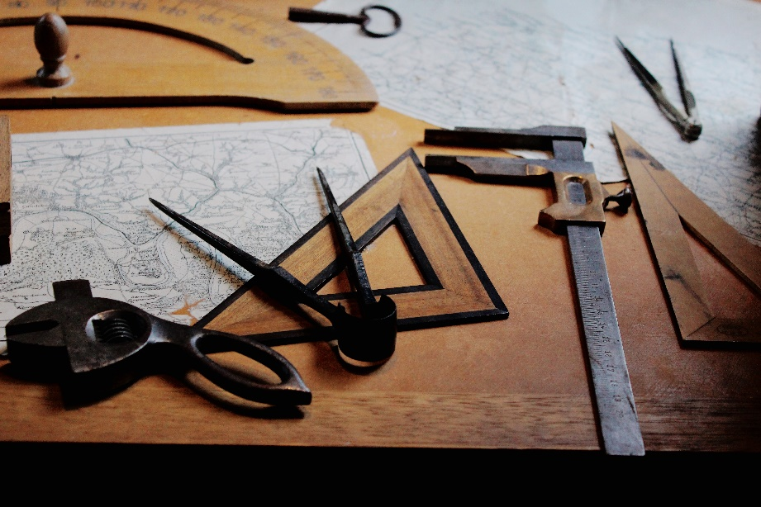

Once the feasibility of your project is ascertained we shall move on to instructing you how we shall collect the 3D scanned date from you. This broken up into two parts: setting up the individual or item to be scanned and the second, the process of recording 3D topographic data of item(s) of interest whilst using handheld 3D scanners.

**PLACEMENT OF DESIRED OBJECTS(S)**

Once we have agreed upon the object of interest that we shall scan for you, we need to optimise the object’s position before being scanned. There are several factors that need to be considered before we scan any object.

* Reflective surfaces
* Ambient lighting
* Transparency

Each of the above need to be assessed before we scan as each factor can result in artefacts that will affect how well the item can be digitally captured with a 3D laser, Infrared and photogrammetry techniques. CC3D principally uses an infrared and colour handheld scanner to capture topographic and colour data respectively for scanned objects; which means the factors above can disrupt us when scanning objects that are either too reflective, poorly light or have transparent qualities. These factors directly affect incoming and outgoing electromagnetic waves which the scanner depends upon to scan objects accurately, in high definition with colour fully realised.

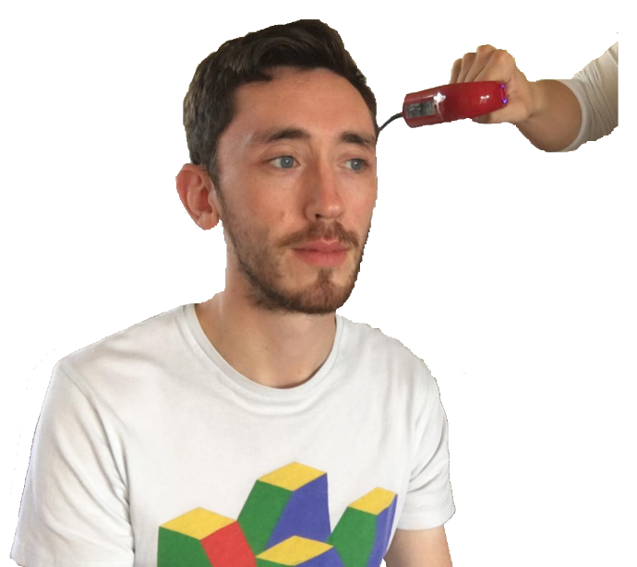

Objects and individuals that are well light under professional or natural lighting will have reduced shadowing affects and will define colour well.

Objects and individuals that have matte coloured surfaces, that aren’t highly glossy with low reflective indexes will be the best to scan, as reflected EM waves produce significantly less noise from matte surfaces.

Transparent materials and surfaces alter the reflective and refractive index of all outgoing EM wave that scanners detect thereby resulting in high levels of unwanted noise and in the worse cases unscannable topographic imagery. When possible we will avoid scanning highly reflective and glossy items of interest, as we know the results might not meet the expectations of our clients. This decision will be made on a case by case basis to decide how to proceed and to inform client(s) of the intended item(s) feasibility to be scanned.

**SCANNING PROCESS**

Once orientated and assessed by CC3D staff, we can proceed by scanning the object(s) or person(s) of interest.

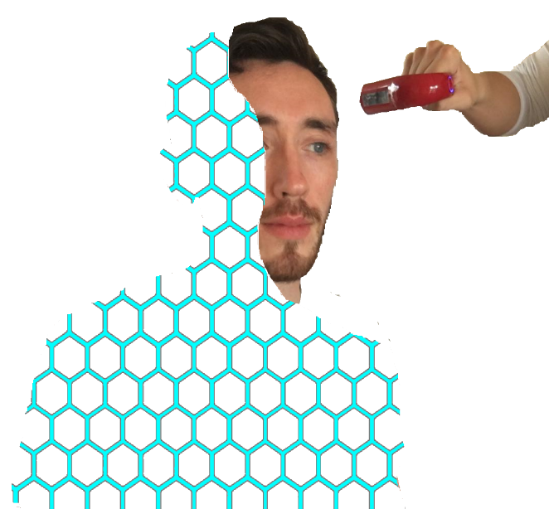

Our 3D scanning software can be set up in various optimised modes for collecting topographic data in several ways. Once the best mode is chosen we shall begin by scanning the object in a fixed position and move around the about within a 3D space. In the case of people being scanned we need to have motionless subjects, any movement will create distortions to the topographic data being recorded and we will likely have to start scans afresh if a movement in the subject is detected.

After some time scanning the object of interest, the amount of topographic detail will increase until the object is fully recognised.

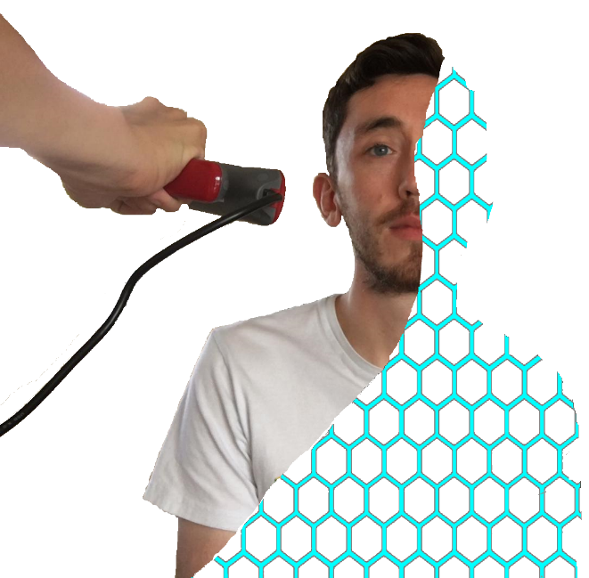

Once all areas and surfaces of the item of interest are scanned, we can stop the scanner recording and allow the software to work its magic in producing a digital representation. When needed, following preliminary analysis of the digitised representation of the item of interest, it may be in our client’s best interests that we redo scans or take repeats of individual scans so that in the following stages we can produce the best 3D digital model possible from the data collected.

**DIGITISATION OF SCANNED OBJECTS**

***ORIGINAL SCANNED DATA***

As previously stated the original copies and repeats of individual items of significant interest are very important to us as they form the base line for all potential CAD processes that may be required for us to create either fully rendered digitised copies of your items of interest or 3D models that can be forwarded on to becoming 3D printable items.

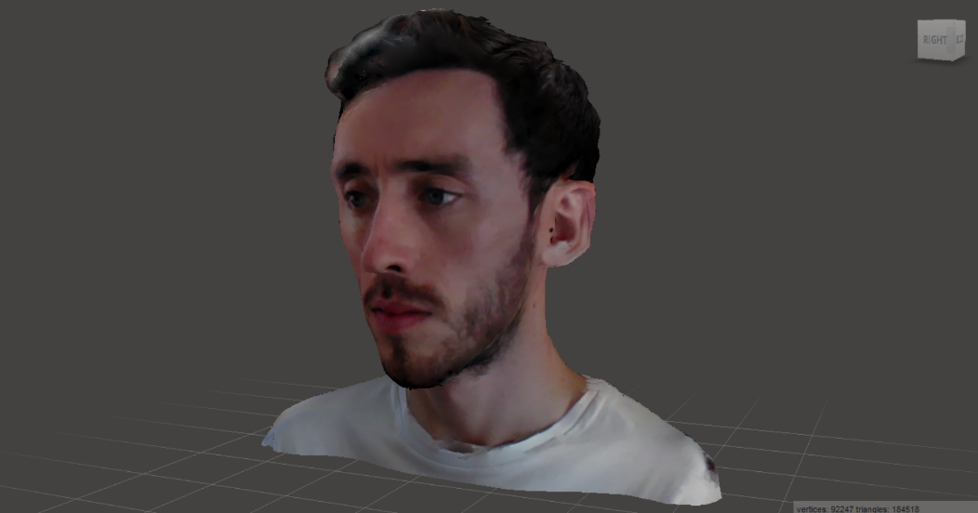

Better quality scanned data reduces the time it will take for CAD manipulation and optimisation, and in general will produce better overall results for you, and will cost less; so deciding when and when not to scan on object of interest is in your best interests as well as our own here at CC3D. The original scanned data essentially forms the benchmark from which all other aspects of your product form, so it is very important that we get this right first time.

***CAD MANIPULATION (0PTIONAL)***

For clients who only which to have the original topographic data, we can produce this as a standalone product for you, but in the majority of cases, the original scanned data will have to manipulated by CC3D to fit the purpose of our clients. CAD on 3D scanned data has unlimited potential, which we can use to unleash all kinds of outcomes for our clients, to meet their needs, specifications and requirements.

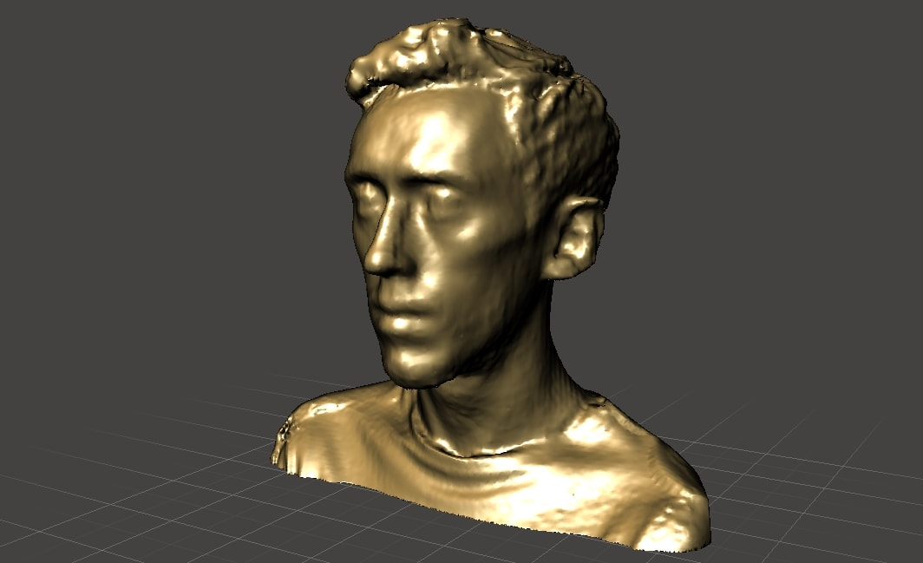

CAD manipulation can produce both aesthetic improvements to digital 3D scans as well as bespoke alterations that some clients may desire, of which may have abstract outcomes required for artistic reasons amongst many others.

Once the manipulation has been completed we can distribute these digital products to our clients in a finished state, or we can take these designs forward onto manufacturing them for our client’s specifications using 3D printing technologies.

***3D PRINTING (OPTIONAL)***

For those who wish to have the scanned data transformed into tangible 3D printed objects, at CC3D we are certainly capable of doing this for you. We will enter your digital 3D models into our 3D printing workflow at our Hub in Cornwall.

Please see how CC3D can help you or your business achieve goals using 3D printing technologies, by following the link below:

[www.collinscreations3d.com](http://www.collinscreations3d.com)

With our 3D printing technologies available for you to use we can help you create a number of real world products, industrial prototypes, art pieces and more…

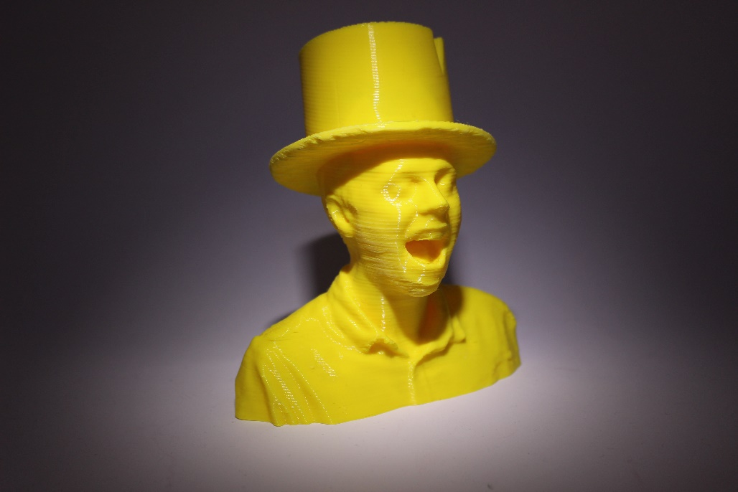

When your items of interest have been 3D scanned and digitally optimised, we can apply all the same principles to 3D scanned data as we can any other 3D models, so let us empower you with these technologies from our range of client service packages available to you.

**PRODUCT DELIVERY**

Scanned 3D objects whose intension are to only remain as digital representations of the original object of significant interest, can be distributed to clients as digital content only.

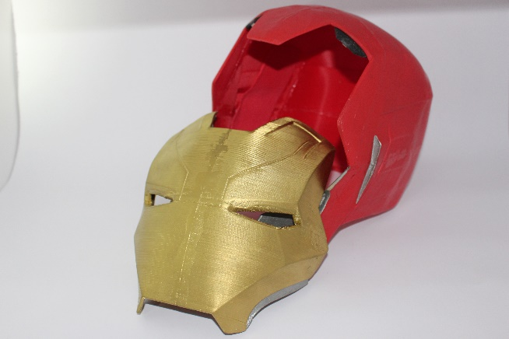

3D scanned digital products that are used for 3D printing physical objects for clients will have to be delivered either in person from one of our CC3D staff members or if the client wishes to receive any digital products along with physical products these can be sent securely by post.

**ADDITIONAL INFORMATION**

The services provided to you by Collins Creations 3D offer unique opportunities to local businesses and individuals who want to innovate, create and experiment with 3D design, manufacture and prototyping. By specialising and utilising 3D Scanning and Printing technologies and methodologies in tandem with one another CC3D can offer you advanced manufacturing services that have not yet been seen in Cornwall, something we hope to change with your help and support.

***Feel free to contact us with further questions, feedback or if you have a design project in mind as an individual, group or business then contact us using the details at the bottom of the page.***